

E-PROJECT!

**FLAVORS**



Group Members:

RABNAWAZ. Student1421395

MUHAMMAD SAAD. Student1413935

MUHAMMAD SAAD. Student1414011

MUHAMMAD SIKANDAR. Student1384023 Submitted to:

Miss **Fatima Siddiqui**

Table of content

Acknowledgement.......................................................................... 3

Introduction .................................................................................... 4

Problem statement.......................................................................... 5

**Executive summary.......................................................................... 5**

Colors and branding........................................................................ 6

Group work...................................................................................... 7

Website Model Screenshot............................................................... 8

Coding screen shot........................................................................... 11

Conclusion ...................................................................................... 13

Acknowledgment:

This web project is the undertaken as a mandatory requirement for the course of front-end development based on" HTML, CSS and Bootstrap" in Aptech learning institute. The aim of this project to design a professional product or service selling website. We have taken great efforts in this project. However, it would not have been possible without the kind support and help of our facilitator Miss Fatima. We would like to extend our sincere thanks to her.

Introduction:

We are a young company, FLAVORS, born of a modern and affordable kitchen. We carry in our DNA the creativity, joy, and entrepreneurial spirit. More than a seasoning brand, FLAVORS is the main ingredient in an incredible story to share: a passion for food.

Good cooking for us is the creative cuisine. We built our product mix uniting aromas and flavors in a unique way, with all the knowledge. Creativity is in the right choices: working with non-industrialized ingredients, choosing long-time producers, and caring for a healthier life. We also combine unique flavors and blends to goals that go beyond a recipe, we want to break prejudices and translate the best traditions of the good table in a current and uncomplicated way.

FLAVORS rethinks how people and businesses relate to each other, and thickens a new gastronomic moment. We believe in the direct and attentive relationship with each client. We architect our products to value the best moments around the table. We are encouraging the culture of eating well and good cuisine. This is the motto that makes us wake up early every day.

Company is involved in trading and manufacturing a wide range of Organic Products and spices to the consumers all around the global market. Company has wide variety of collection of products.

You are supposed to create a Single-Page-Application and responsive Website for them with the below mentioned requirement specifications.

The website is to be developed for the Windows Platform using HTML5, JSON, Angular JS, JavaScript and Geolocation. The site should work well in all leading browsers including Chrome, IE, Firefox etc.

Problem statement:

The portal will be designed as a Single-Page-Application and responsive Website with a set of pages and menus that represent choice of activities to be performed. The pages, menus, and other visual elements must be designed in a visually appealing manner with attractive fonts, colors, and animations.

All of these should also be laid out in a responsive manner

The Web site is to be created based on the following requirements.

1. The Top of the Page should be presented with a suitable logo and banner with images of spices.
2. Sections like Bestsellers, New Arrivals, Hot Deals and Categories should be created with listing of products in these categories.
3. Clicking on a product should open pop-up window with details and images of the spice along with the price. Multiple images should be provided with scrolling option.
4. Gallery should be added for viewing different images.
5. User must be allowed to provide review.
6. Site map, Gallery, about us, Contact us link must be added.
7. About Us and Contact Us: This menu option should display Email id, address, and contact number.
8. Navigation must be made smoother.
9. Uniformity in the designing must be maintained in the website.

Over and above this, the portal should implement the following functionalities:

* Display a continuous scrolling ticker at the bottom of the page with current date, time, and location (hint: Use geolocation features of HTML5).
* Display a visitor count at the top right corner of the page beside a logo image.
* The menu options should change color on hover and also after clicking.
* Fade in and fade out options can be used for the menus.

Executive Summary:

Across Pakistan the businesses are getting towards to E business has seen an explosion of growth over the last few years. Our main competitors our SHAN FOODS have good excess on internet and social pages. They connected and updated prices of products. Our main focus to compete with them and for this we have to update our prices and products on daily basis.

Colors and branding:

The colors we choose **Red**, white and black. The **Red** color shows towards passion. We want our customers to be loyal with our food quality and will always rely on our spices. White background and black text over gave some clean and elegant look to our website. Our logo also based on these colors.

Colors codes:

Red: #af1d1d

 Black: #000000

C:\Users\Ahsan\Desktop\white copy.png White: #FFFFFF

**Logo:**



|  |  |  |  |  |
| --- | --- | --- | --- | --- |
| **No** | **Task** | **Actual Start**  **Date** | **Actual**  **Days** | **Team Members** |
| 1 | Analysis &  Designing | 12-Jan-2023 | 3 | All Members |
| 2 | Development  Home page | 13-Jan-2023 | 3 | MUHAMMAD SAAD. |
| 3 | Further pages  Development | 13-january-2020 | 5 | RABNAWAZ.  MUHAMMAD SAAD MUHAMMAD SIKANDAR. |
| 4 | Testing | 28-Jan-2023 | 2 | RABNAWAZ.  MUHAMMAD SAAD |
| 5 | Documentation | 26-Jan-2023 | 1 | MUHAMMAD SAAD |

Web model

1) Home page:

Screen shot

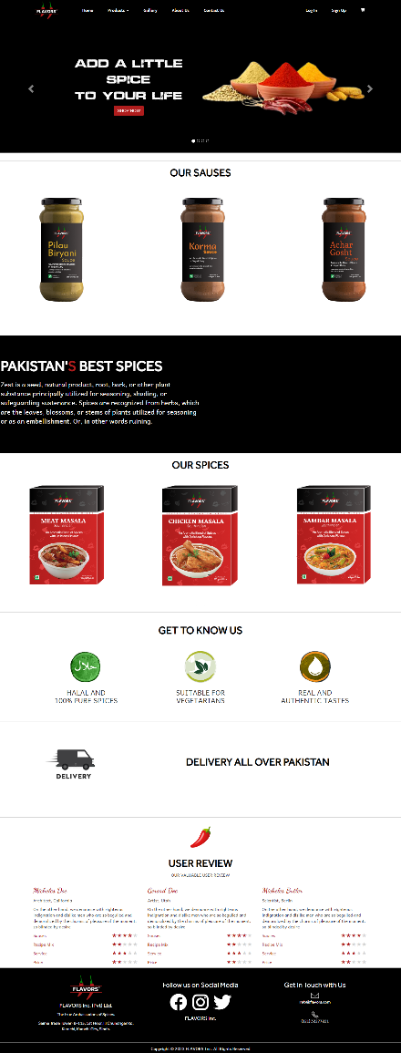

Home page we have header and footer with all info like address, social media link and contact info.

**1a) First section:**

We have carousel with images rotating and some tagline text over that.

**1b) Second section:**

We have our Cooking Sauces products.

**1c) Fourth section:**

It has Our Recipe Mixes Products.

**1d) Fifth section:**

It has our main selling point.

**1e) Sixth section:** It shows our delivery areas.

**1f) Seventh section:** It has review section from our clients.

**1g) Eighth section: It has our footer section.**

2) About Us:

In this page we have all info about our self and what we are selling. We also mention our Best Selling Products there.

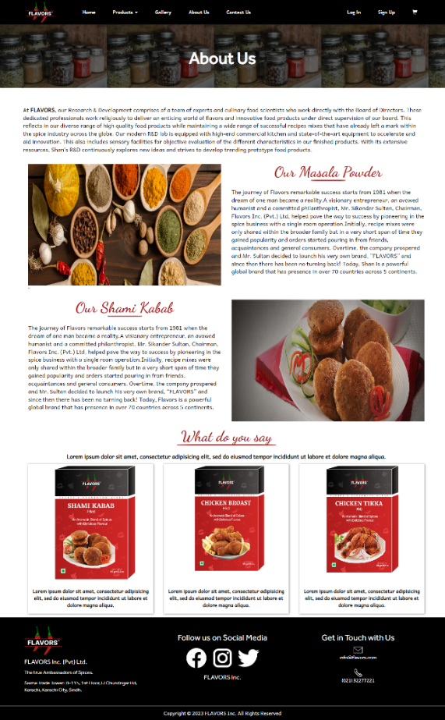

3) Products:

Our products divide into 4 products classes. Cooking Sauces, Recipe Mixes, Plain Spices, Other Products. Product page have all product with names, description and prices. Also, every individual product has its own modal and product details.

Screen Shot

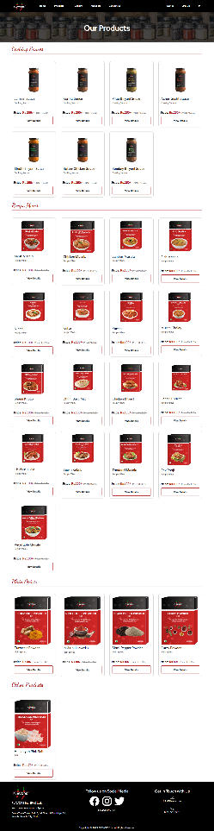

4) Contact us:

Customers can contact us through mail and also have option to see out store position on map.

screen shot

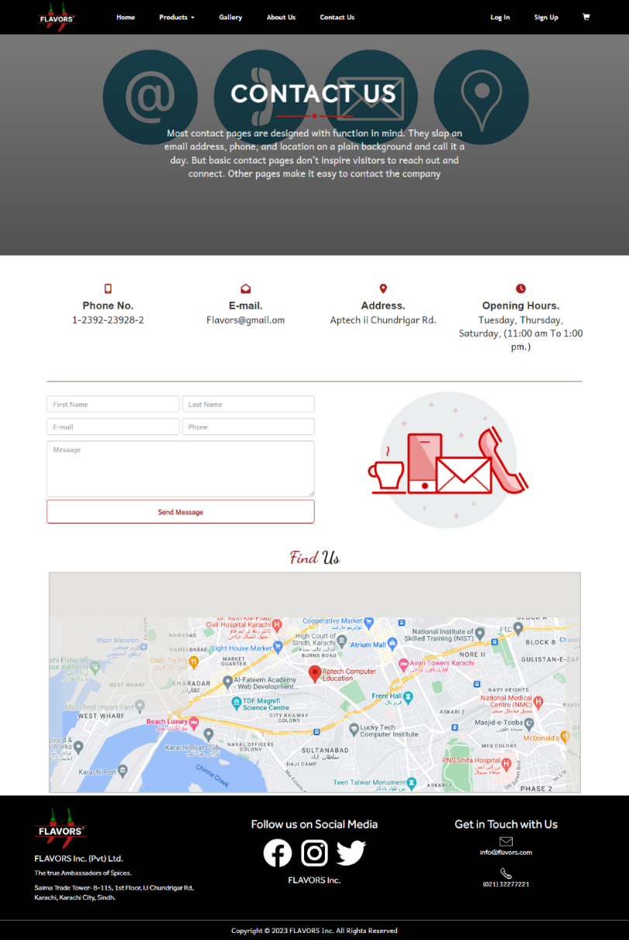

coding sCREEN SHOT

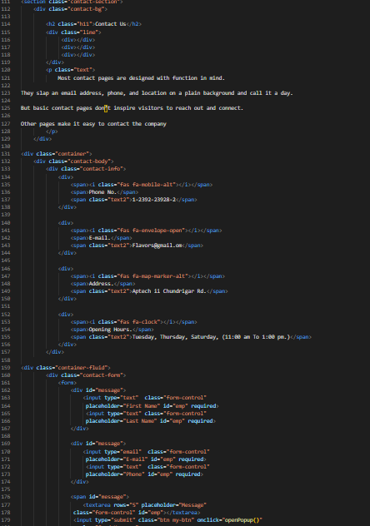 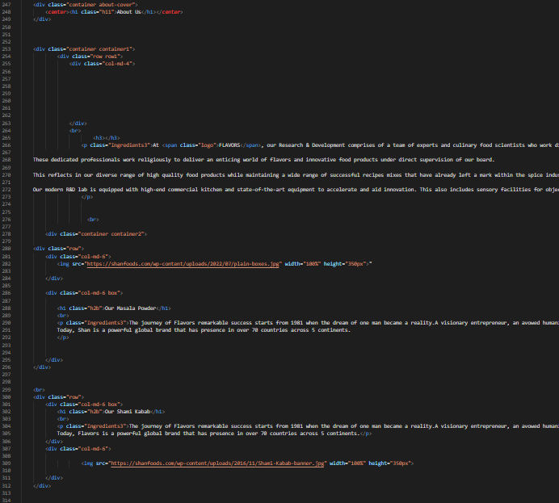

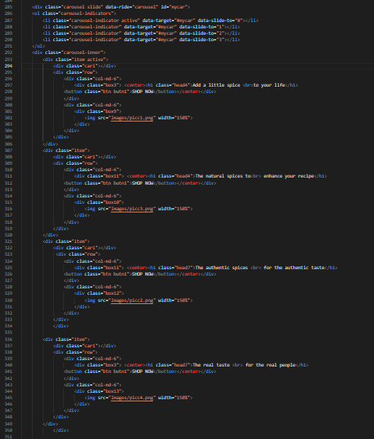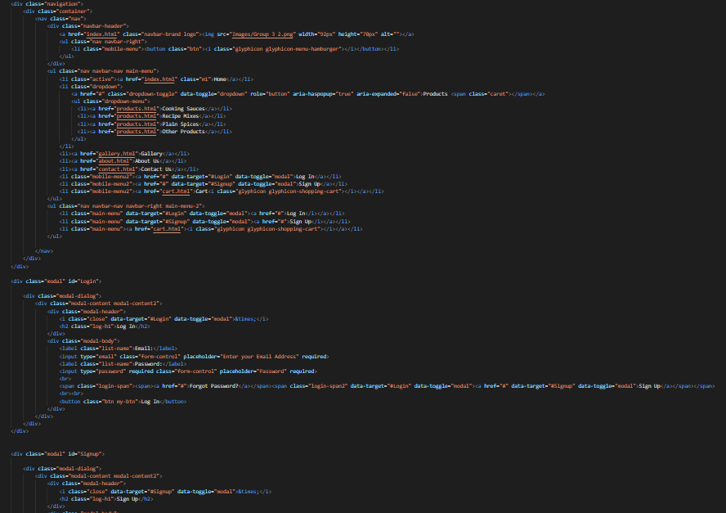

**Conclusion:**

This project primarily base on the Spices store website. The website took some hard efforts in design process, we sort out issues with mutual discussions in group and with the help of kind teacher, who facilitate us to complete the project. Our main aim to target the market with our low-price strategy. We need to update discounted price on daily basis to attract the potential customers and also can add or remove the products any time. The web model easy to understand and not a burdensome for visitors. They can contact us, easy excess to social pages and also can see our address and other info easily.